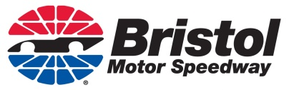

2020 ACCESSIBLE PARKING PERMIT REQUEST
Our records indicate you received accessible parking in 2019 and have submitted the required documentation. If you plan to return for any of the events listed below for the 2020 racing season, please complete and return the information below by the deadline listed. We will not require you to send any additional documents at this time, as we already have them on file.

Name _______________________ Address ___________________________________________

City _________________________ State ______ ZIP __________ Phone ___________________

ACCOUNT # _____________ (If Available)

Fall Race: ____ Truck Race ____ Xfinity Race ____ Monster Energy Cup Race

Seat Location: Grandstand: ________________ Section: ________ Row: ________ Seat(s) ____________

PLEASE RESPOND BY THE FOLLOWING DEADLINE: August 1, 2020

Please be aware that ID matching the permit may be required upon entering the accessible lots at Bristol Motor Speedway. Space is limited in the various parking areas and will be assigned, when possible, based on seating location.

Please feel free to contact our office at any time if you have questions regarding your request or to update your mailing address.

Bristol Motor Speedway
Attn: Crystal Miller
P.O. Box 3966
Bristol, TN 37625
Office: (423) 989-6941 Fax (423) 764-0002
Email: crystal@bristolmotorspeedway.com

