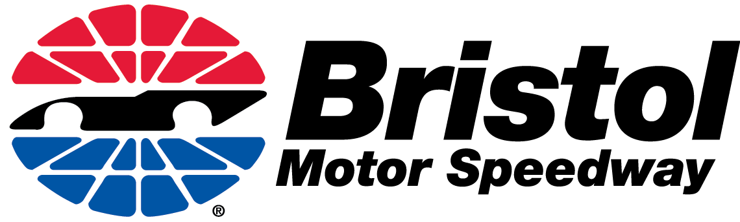

ADVANCE APPLICATION FOR HANDICAP PARKING LOTS ENABLES

SPECIAL NEEDS GUESTS TO PARK CARS CLOSER TO THEIR SEATS

If you, or any member of your party, require handicap parking when attending one of the NASCAR events at Bristol Motor Speedway, we ask that you complete an advance application for a BMS-issued permit. A BMS-issued permit helps guests obtain the closest available handicap parking to their seats.

Anyone planning to use a state-issued placard should send copies of the placard and the supporting documentation in advance, along with this application form, so the BMS Events Department can issue advance permits for the appropriate parking lots. The documentation required (registration card, receipt, state-recognized disabilities ID card, driver’s license, or original approved application forms) is the same reviewed by law enforcement officials at the entrances to handicap lots.

Individuals with temporary disabilities should submit medical documentation with an application to receive the BMS-issued permit.

Space is limited in the various parking areas and will be assigned, when possible, based on seating location as well as first to apply, first served. After applications are received, notification will be sent to the applicant confirming or denying the request. BMS-issued permits will be mailed approximately one month prior to the race.

Law enforcement officials will be at the South and Dragway Entrance checkpoints to ensure that the name on the BMS-issued permit matches a photo ID of the occupant of the vehicle using the permit. Transferring a BMS-issued permit to another person should be considered the same violation of Tennessee law as fraudulently using a state-issued placard.

Guests who do not apply in advance and only have state-issued placards should enter at the Dragway Entrance (Hwy. 394). Law enforcement officials will check documentation to ensure that the person to whom the permit is issued is in the vehicle. If additional parking is available at the time of arrival, guests will be directed to those parking areas.

Please note that these permit procedures do not apply to reserved seat wheelchair guests. Reserved wheelchair seating and parking guests should contact Sherri Long at 423-989-6973.

For all other handicap parking questions, contact Crystal Miller at 423-989-6941 or crystal@bristolmotorspeedway.com.

THE ATTACHED FORM:

2020 Advance Handicap Permit Application
(User must have state-issued handicap placard/plate to apply for this permit)

PLEASE PRINT CLEARLY

Full Name ____________________________________________________________
(as it appears on documentation and photo ID)
Address: _____________________________________________________________
City, State, ZIP _________________________________________________________
Daytime Phone _________________________________________________________
State Issued Plate / Placard Permit Number __________________________________
Email Address _________________________________________________________

SEAT LOCATIONS (please fill out seat information per event attending)
Sept. Truck Series 200 _ _____________________________ Acct # ___________

(Thursday, September 17, 2020) Grandstand Section Row Seat (Or Ticket Holder)
Sept. XFINITY Series 300 _ _ ________ _________________ _ Acct # _________ _

(Friday, September 18, 2020) Grandstand Section Row Seat (Or Ticket Holder)
Sept. Night Race at Bristol ______________________________ Acct # _________ _
(Saturday, September 19, 2020) Grandstand Section Row Seat (Or Ticket Holder)

Note: Seat Location and Ticket Account Number are required. Ticket holder and parking permit user may or may not be the same person. Parking will be assigned by seat location.

Send this COMPLETED form, PLUS a copy of the state-issued permit, PLUS a copy of supporting documentation to obtain or use the permit TO:

ATT: Crystal Miller
BMS Events Dept.
PO Box 3966 _________________________________________________
Bristol, TN 37625 signature of permit user
423-989-6941
423-764-0002 Fax
crystal@bristolmotorspeedway.com

